Beyond the Mound: A Statistical Examination of Walk Rates and Predictive Metrics for Pitchers in the 2024 MLB Season
By Cy Seeley, M.S. Student, Syracuse University
Abstract
This paper investigates the relationship between various pitching metrics and performance outcomes in Major League Baseball (MLB). Specifically, it addresses two critical research questions: (1) Is there a difference in sweet spot percentage allowed between pitchers with high walk rates and those with low walk rates? (2) Can a pitcher’s expected weighted On-Base Average (xwOBA) be accurately predicted based on their whiff percentage, swing percentage, and batted ball metrics such as sweet spot and hard-hit percentages? Utilizing advanced statistical data from Baseball Savant, this analysis examines the intricacies of pitching effectiveness and the influence of specific metrics on offensive performance. The findings aim to enhance understanding of pitching strategies, inform coaching decisions, and contribute to player development by uncovering patterns that illustrate the correlations between these metrics and overall performance outcomes.
Introduction
In the world of Major League Baseball (MLB), understanding pitching performance is crucial for teams seeking a competitive edge. Pitchers play a pivotal role in their teams' success, and their ability to control the game often determines the outcome of a season. Effective pitching can disrupt a team's rhythm, lower their scoring potential, and influence overall standings. Thus, analyzing pitching metrics can provide valuable insights that help teams optimize strategies and make informed decisions regarding player development and in-game tactics.
This analysis aims to explore two significant research questions: First, is there a difference in sweet spot percentage allowed between pitchers with high walk rates and those with low walk rates? Second, can a pitcher’s expected weighted On-Base Average (xwOBA) be accurately predicted based on their whiff percentage, swing percentage, and batted ball metrics such as sweet spot and hard-hit percentages?
These questions are vital as they delve into the intricacies of pitching effectiveness and the factors that influence offensive performance against pitchers. By examining the relationship between walk rates and sweet spot percentages, teams can identify strategies that minimize hitters' chances of connecting with the ball in advantageous positions. High walk rates often lead to scoring opportunities for opposing teams; therefore, understanding how this metric correlates with sweet spot percentages can guide pitchers in refining their approach on the mound. Furthermore, predicting xwOBA using various pitching metrics provides insights into how a pitcher's performance correlates with offensive outcomes, ultimately informing coaching decisions and player development.
To conduct this analysis, I utilized data obtained from Baseball Savant, a comprehensive resource that provides advanced statistics and analytics for MLB players. This data offers valuable insights into pitching performance, allowing for a deeper understanding of the elements contributing to success on the mound. Through this examination, I aim to uncover meaningful patterns and correlations that can aid in evaluating pitching talent and the strategic decision-making process in baseball.
Methods and Models
Data Collection
The dataset used in this analysis was obtained from Baseball Savant, a reputable source for advanced MLB statistics. It includes various pitching metrics for the 2024 MLB season, encompassing key statistics such as last name, first name, player ID, plate appearances (pa), strikeout percentage (k_percent), walk percentage (bb_percent), expected weighted On-Base Average (xwOBA), weighted On-Base Average (wOBA), sweet spot percentage, barrel batted rate, hard-hit percentage, average best speed, average hyper speed, whiff percentage, and swing percentage. The data was imported as an Excel file, ensuring a structured approach to analyzing these important metrics.
Data Preparation
Before conducting the analysis, the dataset underwent a thorough cleaning and preparation process. This involved handling any missing values, converting necessary columns to appropriate data types, and ensuring that all metrics were correctly formatted for analysis. Key variables were identified for the research questions, specifically focusing on walk rates, sweet spot percentages, and other relevant pitching metrics.
Statistical Analysis
To address the first research question regarding the difference in sweet spot percentages based on walk rates, a t-test was performed. The dataset was divided into two groups based on the median walk percentage: high walk rate pitchers (above the median) and low walk rate pitchers (at or below the median). The t-test yielded a t-statistic of -0.14 and a p-value of 0.8887, indicating no statistically significant difference in sweet spot percentages between these two groups. This result suggests that a pitcher’s walk rate does not influence the likelihood of allowing contact in the sweet spot area, which is critical for understanding offensive potential against pitchers.
For the second research question concerning the prediction of xwOBA, a linear regression model was utilized. The independent variables included whiff percentage, swing percentage, sweet spot percentage, and hard-hit percentage. The dataset was divided into training and testing sets using an 80-20 split to evaluate the model's predictive performance. The linear regression model was fitted to the training data, and predictions were made on the test set. The Mean Squared Error (MSE) of the model was found to be 0.0001, indicating that the model's predictions are very close to the actual xwOBA values. The R-squared value of 0.6357 suggests that approximately 63.57% of the variance in xwOBA can be explained by the selected metrics.
The model indicates that pitchers with higher whiff percentages and swing percentages tend to allow lower xwOBA values, while higher sweet spot and hard-hit percentages are associated with increased xwOBA. These findings underscore the importance of contact management in pitching strategy.
Results and Key Takeaways
The analysis yielded important insights into the two primary research questions regarding pitching performance in the 2024 MLB season.
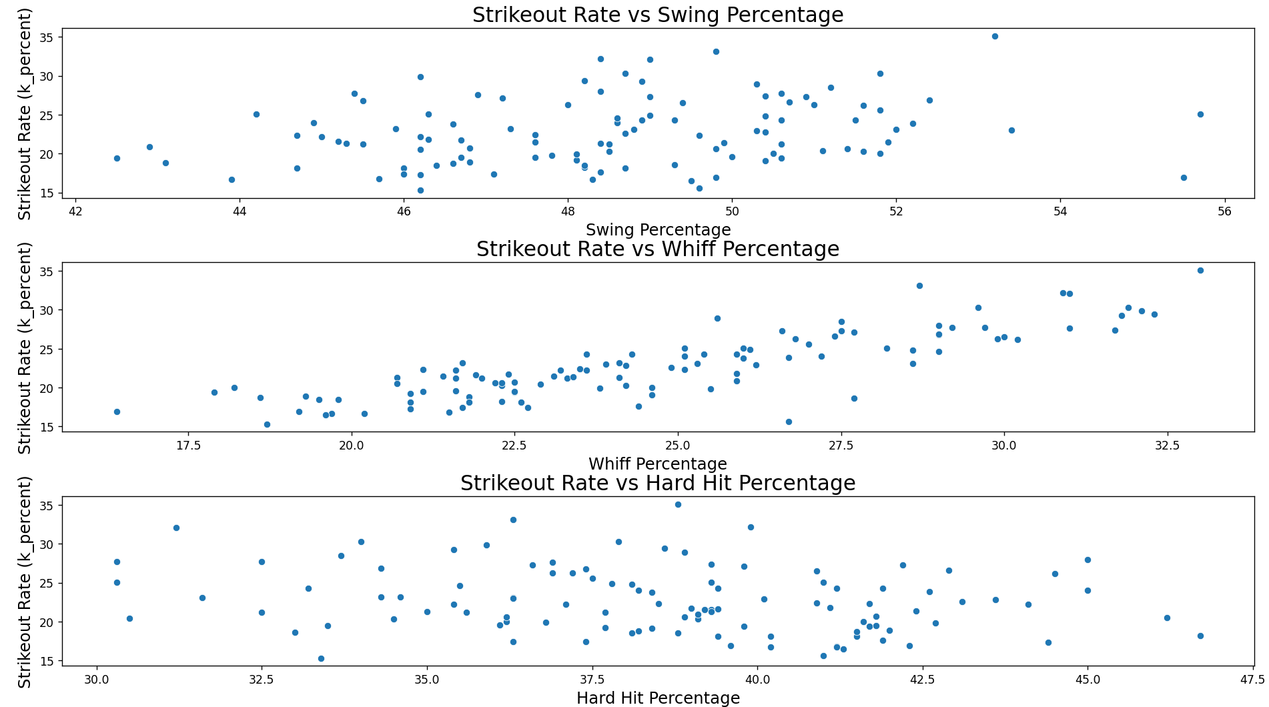
Here's a refined version of your results section:

The scatter plots illustrate the relationships between strikeout rate (k_percent) and three different pitching metrics: swing percentage, whiff percentage, and hard-hit percentage. The first plot indicates that there is no clear trend or strong correlation between swing percentage and strikeout rate, suggesting that swing rate alone does not effectively predict strikeout performance. In the second plot, a noticeable positive trend is observed between whiff percentage and strikeout rate, indicating that higher whiff rates tend to be associated with higher strikeout rates. The third plot demonstrates that the relationship between hard-hit percentage and strikeout rate is relatively weak, lacking a distinct pattern, which suggests that hard-hit percentage does not directly correlate with strikeout rates. Overall, whiff percentage emerges as the most significant predictor of strikeout performance among the three metrics.
- Difference in Sweet Spot Percentage by Walk Rates: The t-test conducted to evaluate the difference in sweet spot percentages between high and low walk rate pitchers revealed a t-statistic of -0.14 and a p-value of 0.8887. These results indicate that there is no statistically significant difference in sweet spot percentages between the two groups. Consequently, this analysis suggests that a pitcher’s walk rate does not influence the likelihood of allowing contact in the sweet spot area, which is critical for understanding offensive potential against pitchers.
- Prediction of xwOBA: The linear regression model was successfully fitted to predict xwOBA using whiff percentage, swing percentage, sweet spot percentage, and hard-hit percentage as predictors. The Mean Squared Error (MSE) of the model was found to be 0.0001, indicating that the model's predictions are very close to the actual xwOBA values. The R-squared value of 0.6357 suggests that approximately 63.57% of the variance in xwOBA can be explained by the selected metric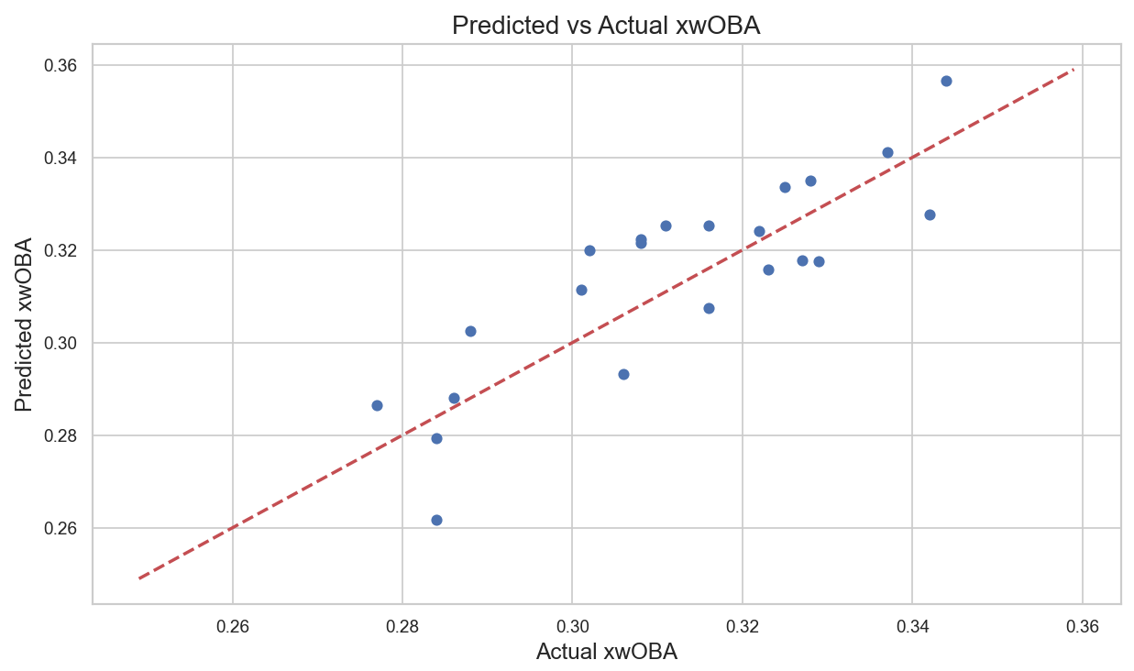
The coefficients of the model provide further insights into the relationships among the variables:
- Whiff Percentage: A coefficient of -0.002559 indicates that higher whiff rates correlate with lower expected offensive outcomes against pitchers.
- Swing Percentage: The coefficient of -0.002959 suggests that an increase in swing percentage is also associated with lower xwOBA.
- Sweet Spot Percentage: A positive coefficient of 0.003409 implies that a higher sweet spot percentage correlates with increased offensive effectiveness, as indicated by higher xwOBA.
- Hard-Hit Percentage: The coefficient of 0.002121 indicates that allowing harder-hit balls is associated with increased xwOBA.
Key Takeaways
- Walk Rates and Sweet Spot Percentage: The lack of a significant difference in sweet spot percentages between high and low walk rate pitchers implies that factors other than walk rates may be more influential in determining a pitcher's ability to minimize hard contact. This finding suggests the need for further exploration into other metrics, such as pitch selection or defensive support.
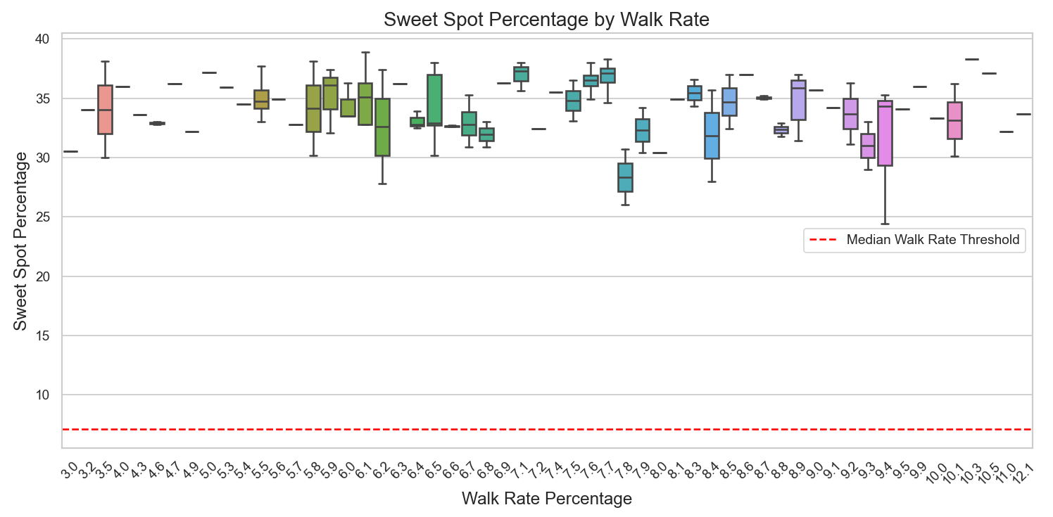
The box plot illustrates the distribution of sweet spot percentages across various walk rate percentages among pitchers. Each box represents the interquartile range (IQR) of sweet spot percentages for pitchers within a specific walk rate group, with the median value indicated by the central line within each box. The red dashed line marks the median walk rate threshold used to distinguish between high and low walk rate pitchers. The plot reveals that sweet spot percentages generally vary across different walk rate groups, with some groups exhibiting a wider range and others showing more compact distributions. However, the visual does not indicate a consistent pattern or clear relationship between walk rate percentage and sweet spot percentage. This suggests that while walk rate might influence sweet spot percentage to some extent, other factors likely play a more significant role in determining these percentages.
Key Takeaways
- Predictive Power of Metrics: The linear regression model demonstrated the effectiveness of using whiff percentage, swing percentage, sweet spot percentage, and hard-hit percentage to predict xwOBA. With an R-squared value exceeding 0.60, these metrics collectively offer valuable insights into a pitcher’s expected performance, aiding teams in decision-making regarding player evaluations and strategic planning.
- Focus on Contact Management: The analysis emphasizes the importance of minimizing sweet spot and hard-hit percentages, as these metrics are directly linked to offensive outcomes. Pitchers who excel at inducing swings and misses (higher whiff percentages) and limiting contact quality (lower sweet spot and hard-hit percentages) are likely to achieve better results on the mound.
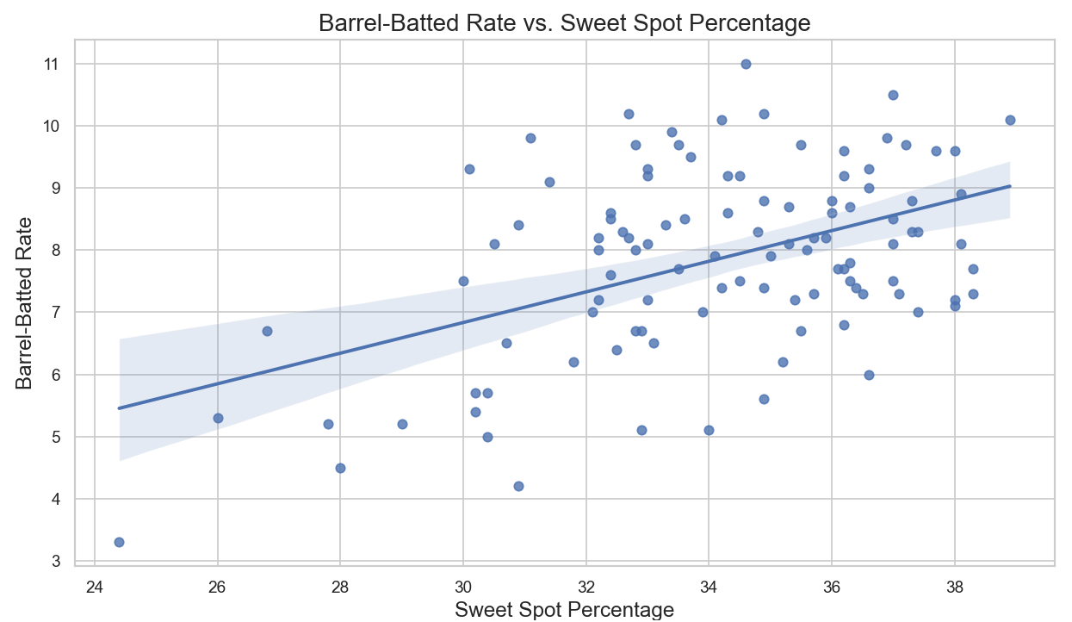
The scatter plot with a regression line illustrates the relationship between sweet spot percentage and barrel-batted rate among pitchers. The data points are dispersed throughout the plot, and the regression line indicates a positive trend, suggesting that as the sweet spot percentage increases, the barrel-batted rate tends to rise as well. The shaded area around the regression line represents the confidence interval, illustrating the variability of the relationship. This trend implies that pitchers who allow a higher percentage of hits in the sweet spot zone are also likely to have a higher barrel-batted rate, indicating a propensity for giving up high-quality contact. However, the scatter of data points around the line suggests that while there is a positive relationship, it may not be strong, indicating that other factors likely influence the barrel-batted rate. Overall, the findings from this analysis provide actionable insights for teams and coaches in understanding pitching performance and identifying areas for improvement.
Conclusion
This analysis explored critical questions surrounding pitching performance in the 2024 MLB season, focusing on the relationship between walk rates and sweet spot percentages, as well as the predictability of a pitcher's expected weighted On-Base Average (xwOBA) based on various pitching metrics. By leveraging data from Baseball Savant, valuable insights were gained into how these factors influence offensive outcomes against pitchers.
The results indicated that walk rates do not significantly impact the sweet spot percentage allowed by pitchers, suggesting that other elements, such as pitch selection and overall pitching strategy, may play more prominent roles in determining contact quality. Furthermore, the linear regression model demonstrated the potential of using metrics like whiff percentage, swing percentage, sweet spot percentage, and hard-hit percentage to accurately predict xwOBA, with a commendable level of explained variance.
These findings underscore the importance of contact management in pitching. Pitchers who can effectively induce swings and misses while minimizing high-quality contact are likely to experience more favorable outcomes. By understanding these relationships, teams can make more informed decisions regarding player evaluation, coaching strategies, and in-game tactics.
In conclusion, the insights derived from this analysis not only contribute to the ongoing discourse on pitching performance in baseball but also serve as a foundation for future research aimed at enhancing player development and optimizing team strategies. As the game evolves, continued exploration of advanced metrics will be essential in identifying the nuances of pitching effectiveness and its impact on overall team success.
Possible Improvements and Further Questions
Possible Improvements
- Expanded Dataset: Future analyses could benefit from a larger and more comprehensive dataset that incorporates multiple seasons of pitching statistics. This would enable a more robust exploration of trends over time and enhance the generalizability of the findings.
- Incorporating Additional Metrics: Including additional performance metrics, such as pitch type distribution, pitch velocity, and spin rates, could provide a deeper understanding of how these factors influence both sweet spot percentage and xwOBA. Analyzing how different pitch types affect hitter outcomes may yield valuable insights.
- Advanced Statistical Techniques: Employing more sophisticated statistical techniques, such as machine learning models, could improve predictive accuracy for xwOBA. Techniques like random forests or gradient boosting could capture complex relationships among the variables that traditional regression may overlook.
Further Questions
- How do specific pitch types influence sweet spot percentage and xwOBA? Understanding the impact of different pitch types on contact quality could help identify pitchers who excel at limiting high-quality contact.
- What role does defensive support play in a pitcher’s ability to minimize sweet spot percentages? Investigating how fielding performance correlates with pitching outcomes may provide insights into the broader context of a pitcher's effectiveness.
- How do environmental factors, such as ballpark dimensions and weather conditions, affect pitching performance metrics? Analyzing how these external factors influence pitching outcomes could enhance team strategies when preparing for games in various conditions.
By addressing these potential improvements and questions, future research can continue to advance the understanding of pitching performance in Major League Baseball, ultimately contributing to the development of more effective pitching strategies and player evaluations.

References
- Baseball Savant. (2024). MLB Advanced Statistics & Analytics. Retrieved from https://baseballsavant.mlb.com
- MLB.com. (2024). Standard Stats Glossary. Retrieved from https://www.mlb.com/glossary/standard-stats
- MLB.com. (2024). Advanced Stats Glossary. Retrieved from https://www.mlb.com/glossary/advanced-stats
- Pitcher List. (2024). Baseball Stats Glossary. Retrieved from https://pitcherlist.com/baseball-stats-glossary/

