Decoding the Market: Insights into Stock Prices and Trading Patterns
By Cy Seeley, M.S. Student, Syracuse University

Abstract
This study analyzes 846,404 stock trading records to uncover patterns, anomalies, and key insights into market behavior. Metrics such as closing prices, trading volumes, and percentage price changes were examined using statistical and visualization techniques. Key findings include the stock with the highest closing price, trends in trading volume over time, and significant correlations among key variables. Additionally, the analysis identifies potential anomalies and provides recommendations for further research.

Introduction
The stock market is a dynamic and data-rich environment, reflecting investor sentiment, economic conditions, and market activity. This study explores a dataset of over 846,000 stock trading records to uncover patterns and relationships between key metrics, such as opening and closing prices, trading volumes, and percentage price changes. With detailed information on stocks and their trading behavior over time, the analysis provides insights into market dynamics and identifies anomalies worthy of further investigation.
This paper aims to answer critical questions: Which stocks exhibit the highest trading activity? How do price trends evolve over time? What correlations exist among key variables, and how might they inform trading strategies? Using statistical analysis and visual tools, this study aims to provide actionable insights for investors, analysts, and researchers.

Data Preparation
The dataset includes 13 columns, such as SYMBOL, SERIES, CLOSE, TOTTRDQTY, and TOTTRDVAL. Data cleaning focused on handling missing values, especially in the SERIES column, and converting the TIMESTAMP column into a datetime format for temporal analysis.
A new feature, PCT_CHANGE, was created to calculate the percentage difference between opening and closing prices, allowing daily stock performance to be quantified. Summary statistics were computed to understand the data distribution, and unique value counts identified potential biases or irregularities. These steps ensured a clean and reliable dataset for analysis.

Methods and Models
This study employed a combination of statistical and visualization techniques to analyze the data. Descriptive statistics, including mean and standard deviation, summarized key variables, while visualizations, such as histograms and line charts, revealed trends and distributions.
Correlation analysis, visualized through a heatmap, identified relationships among variables like OPEN, HIGH, LOW, and CLOSE. Anomalies in trading volumes were highlighted using boxplots, while group-by operations revealed stocks with the highest average traded volumes. Predictive modeling using a Random Forest algorithm provided insights into the importance of various features in predicting closing prices.

Analysis
The histogram reveals an extreme right skew, with the majority of closing prices clustered at lower values and very few instances of higher prices. This indicates a heavily imbalanced distribution, likely driven by outlier stocks with exceptionally high prices. Such a pattern suggests the data may need transformation (e.g., log or square root) to reduce skewness before applying statistical or predictive modeling. Additionally, this distribution could indicate the presence of different tiers in the stock market (e.g., small-cap vs. large-cap companies), which may influence downstream analyses.
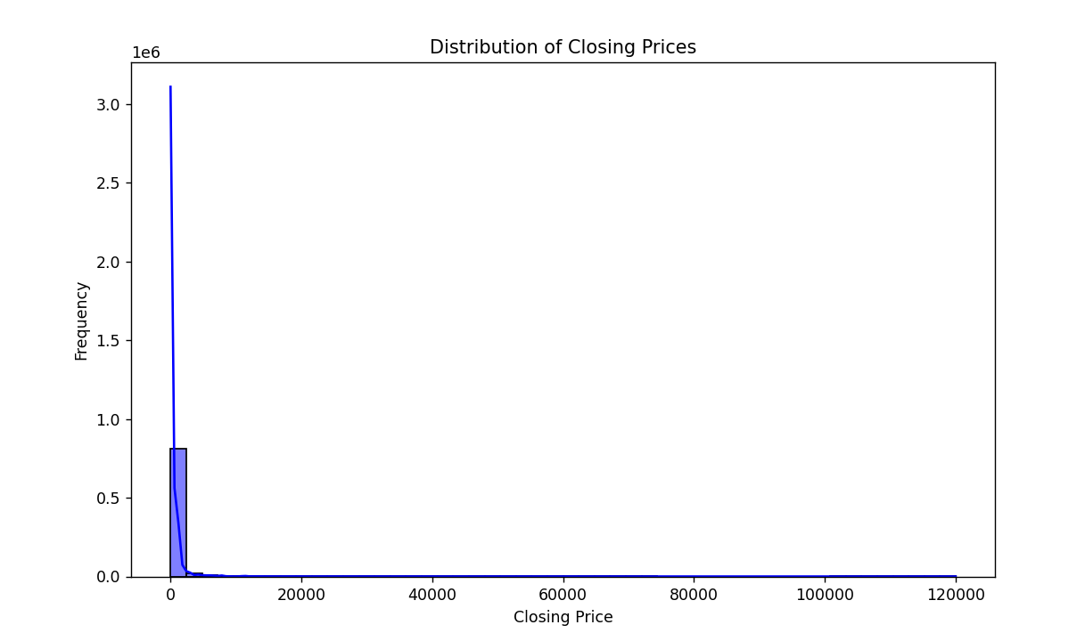
The time-series plot of total traded quantity over time shows fluctuations, with notable spikes and dips. There are periods of increased trading activity, particularly towards the end of the timeline, which could indicate heightened market activity, economic events, or speculative trading. Conversely, the periods with sharp drops suggest temporary market inactivity or anomalies. The increasing volatility over time might suggest a dynamic trading environment or shifts in market conditions, which could be investigated further. Identifying specific dates of significant spikes and correlating them with external events (e.g., policy changes, earnings reports) might provide richer context for these patterns.
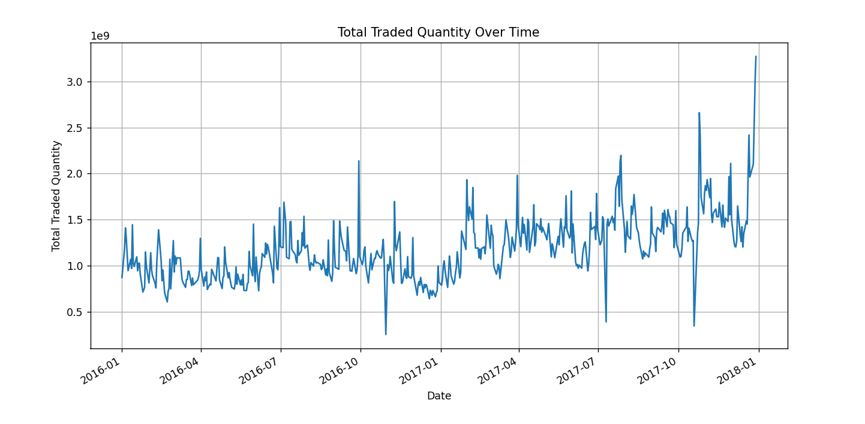
The heatmap reveals strong positive correlations (values close to 1.00) among the OPEN, HIGH, LOW, and CLOSE variables, indicating that these features move together consistently. This is expected since they reflect different aspects of daily stock price fluctuations. In contrast, TOTAL TRADED QUANTITY (TOTTRDQTY) and TOTAL TRADED VALUE (TOTTRDVAL) exhibit weak or negligible correlations with the price-related variables, as shown by values near zero. This suggests that while prices are interdependent, trading activity may not directly influence or align with daily price movements. This insight could influence feature engineering, as price variables may dominate predictive models, while volume-related variables could have secondary importance.
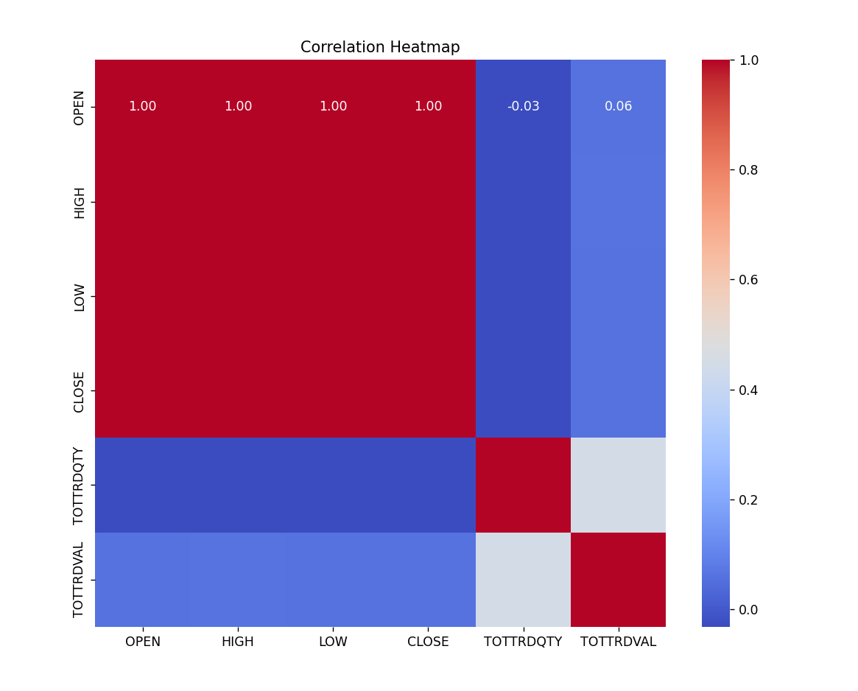
The boxplot of the total traded quantity shows a significant number of outliers on the higher end of the distribution, indicating that there are days or transactions with exceptionally large traded quantities compared to the rest of the dataset. The dense clustering of values near the lower end suggests that most transactions involve smaller quantities. The long range of outliers highlights variability in market activity, which could be driven by external events or specific trading patterns. This visualization emphasizes the need for preprocessing steps (e.g., outlier handling or scaling) if the analysis involves models sensitive to skewness or extreme values. It also suggests a potential area for deeper investigation into what causes these outlier transactions.
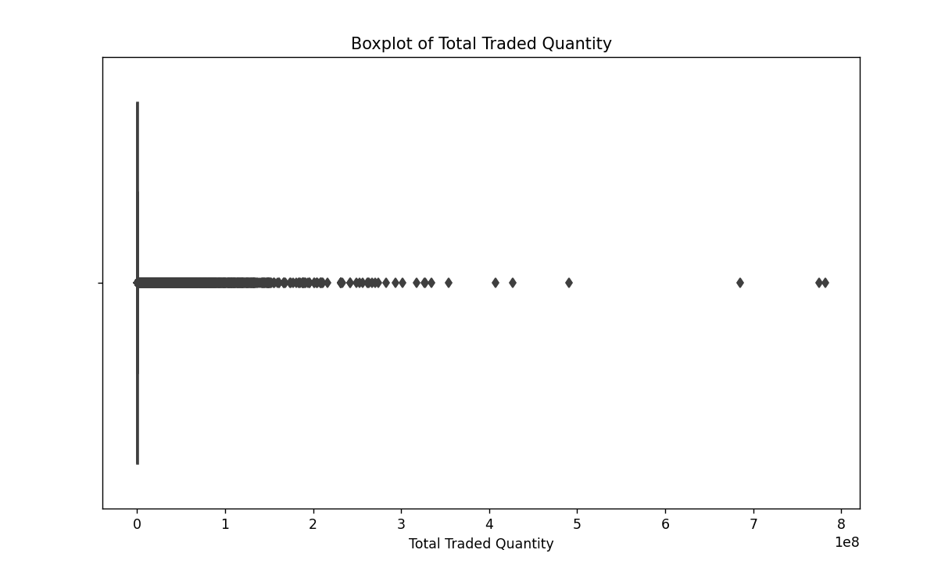
To explore the relationship between stock features and their predictive ability for closing prices, a Random Forest model was implemented. The feature importance scores reveal that the HIGH price holds the greatest predictive power in determining the closing price, with a feature importance score exceeding 0.5. This indicates a strong correlation between the day's highest price and the closing price, emphasizing its relevance in the stock market. The OPEN and LOW prices follow, with moderate importance scores, highlighting their secondary but notable contribution to the model. Interestingly, the total traded quantity (TOTTRDQTY) showed minimal importance, suggesting that trading volume alone has limited predictive value for the closing price compared to price-related features. This insight supports the notion that price patterns and fluctuations during trading hours carry more weight in forecasting closing prices, which could guide investors and analysts in their strategies.
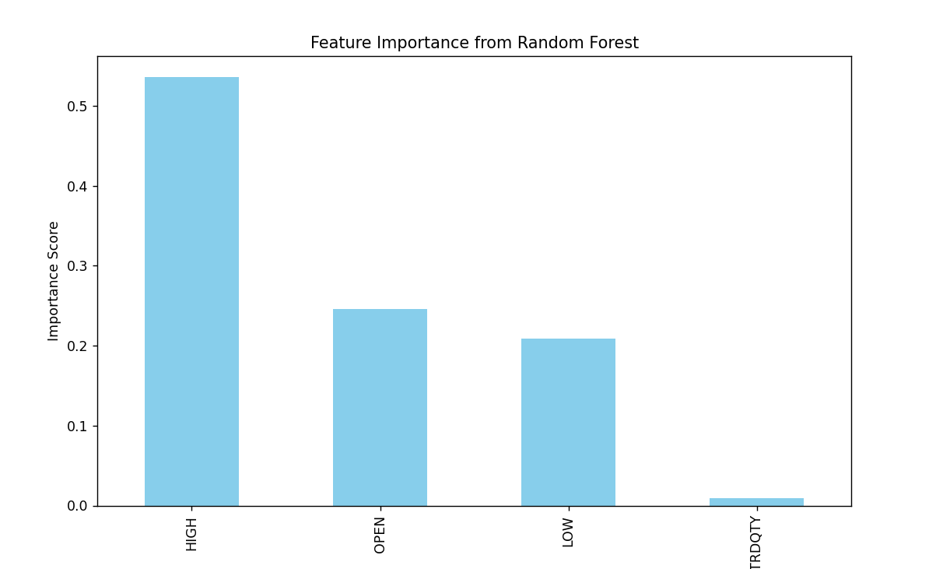

Results
The analysis of the dataset uncovered several key findings about stock performance, trading activity, price trends, and anomalies. One notable observation was the exceptional performance of the stock PEL, which recorded the highest closing price of 119,990 on December 8, 2017, reflecting its premium valuation compared to other stocks. Such a high value indicates its market dominance or unique characteristics within the dataset.
In terms of trading activity, the dataset revealed an average trading volume of approximately 698,380 units, showcasing significant market engagement. Certain stocks, such as JPASSOCIAT, SUZLON, and UNITECH, stood out for their exceptionally high average traded volumes, marking them as dominant players in the market. These stocks likely attract considerable attention from traders due to their liquidity or other market-driving factors.
Price trends showed a slight average percentage change of -0.17% between opening and closing prices, suggesting a subtle downward trend over the dataset's timeframe. This could reflect broader market sentiment or investor caution during the period of analysis. Strong positive correlations among key price variables, such as OPEN, HIGH, LOW, and CLOSE, confirmed their interdependence and consistent movement, aligning with expectations of daily stock price fluctuations. However, trading activity metrics like TOTAL TRADED QUANTITY and TOTAL TRADED VALUE exhibited weaker relationships with price variables, suggesting that trading volume does not significantly influence daily price movements.
Finally, the analysis highlighted notable anomalies in trading volumes. Outliers on the higher end of the volume distribution indicated irregular market behavior or potential data quality issues. These extreme values likely represent days of unusually high trading activity, possibly driven by external factors such as economic events, earnings reports, or speculative trading. Identifying and investigating these anomalies further could provide valuable insights into unique market dynamics or irregular patterns within the dataset.

Key Takeaways
- Price variables (OPEN, HIGH, LOW, CLOSE) exhibit strong interdependence, driving stock performance analysis.
- Trading volumes are dominated by highly active stocks, with noticeable anomalies suggesting irregular patterns.
- A minor downward trend in stock prices reflects broader market caution or bearish sentiment.

Conclusion
This study demonstrates the potential of stock market data to uncover meaningful insights and inform trading strategies. By analyzing metrics such as closing prices, trading volumes, and percentage changes, the findings provide a comprehensive overview of market behavior.
The results highlight the importance of price metrics in predictive modeling while identifying areas for improvement, such as incorporating macroeconomic indicators to contextualize stock trends. Further investigation into anomalies in trading volumes could reveal unusual market behaviors or data inconsistencies.
By combining statistical analysis with visual tools, this study underscores the value of data-driven decision-making in the stock market, offering valuable insights for investors and researchers alike.

Possible Improvements
- Incorporating External Data: Merging stock data with macroeconomic indicators or news sentiment could provide richer context for market behaviors.
- Handling Skewness: Transforming highly skewed variables could improve the robustness of predictive models.
- Exploring Anomalies: A deeper investigation into outlier trading volumes could identify the underlying causes of irregular market activity.

