Unveiling Housing Market Dynamics: A Data-Driven Analysis of Price Trends, Clusters, and Correlations
By Cy Seeley M.S. Student, Syracuse University
Abstract
This paper explores the dynamics of the U.S. housing market using a large real estate dataset containing over two million records. The analysis delves into housing prices, property sizes, and temporal trends through comprehensive data preparation, statistical methods, and advanced visualization techniques. Findings highlight key insights such as the relationship between house size and price, significant regional variations in average housing prices, and clustering patterns in price per acre. This research serves as a foundation for understanding the housing market's complexities and provides actionable insights for stakeholders such as buyers, sellers, and policymakers.

Introduction
The U.S. housing market plays a vital role in the nation’s economy, reflecting both regional and national trends in real estate. Housing prices, property sizes, and trends over time are key indicators of market dynamics that influence decisions made by buyers, sellers, investors, and policymakers. However, the market is complex, with diverse factors influencing property values, from house size and location to economic conditions and buyer preferences.
This study uses a comprehensive dataset to examine critical aspects of the housing market, such as the distribution of property values, correlations between house size and price, and temporal trends in housing prices. The analysis incorporates both statistical techniques and machine learning methods, such as clustering, to uncover patterns and actionable insights. By leveraging advanced visualizations, this paper provides a nuanced understanding of market trends and regional disparities, offering readers a well-rounded perspective on the U.S. housing market.

Data Preparation
Extensive cleaning and preprocessing were essential to ensure the dataset’s accuracy and reliability. Rows with missing values in critical columns such as price, house size, and acreage were removed. Numerical variables, including price and house size, were converted to appropriate formats, while date columns, such as "previously sold date," were transformed into datetime objects to enable temporal analysis.
Extreme outliers were addressed by filtering acre lot sizes below 0.01 and prices exceeding $2 billion to prevent skewed results. Additionally, log transformations were applied to highly skewed variables like price and house size to normalize distributions and improve interpretability.
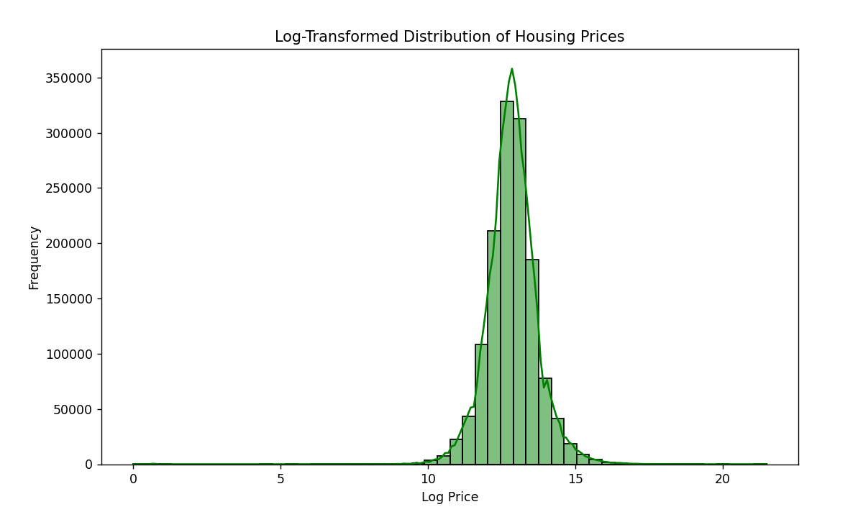
These steps ensured the dataset was robust for statistical analysis and visualization, minimizing bias from extreme values while retaining meaningful trends.

Analysis
Descriptive Statistics and Price Distribution
The dataset revealed critical trends in housing prices and property sizes. Housing prices ranged widely, from $0 to $2.15 billion, with a mean of $577,972 and a median of $379,000. A high standard deviation of $2.2 million underscored the presence of extreme outliers.
Most properties were valued below $1 million, creating a highly skewed distribution. This prompted the application of log transformations to better visualize and interpret the data.
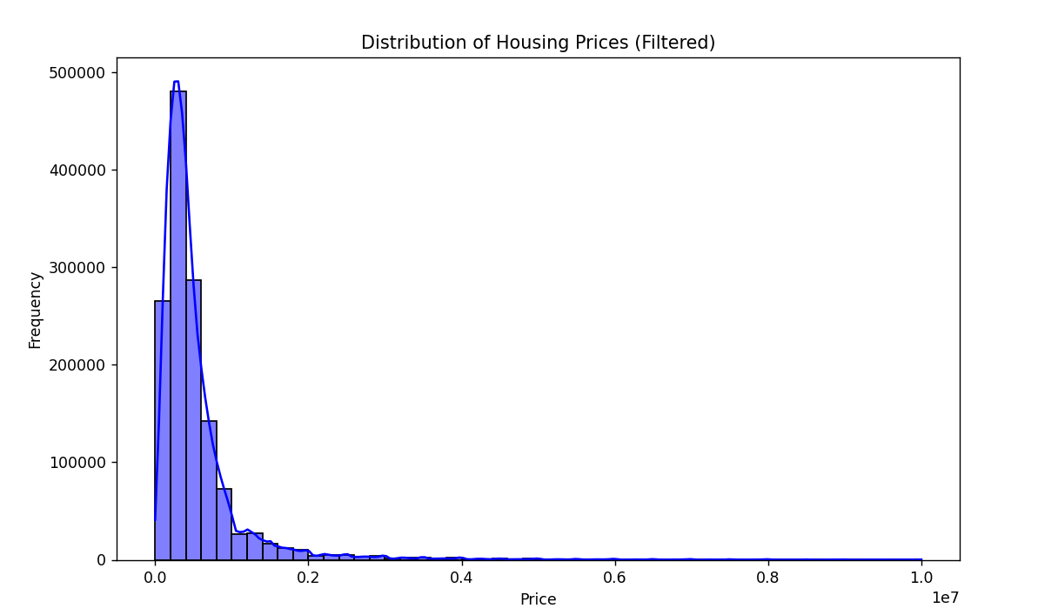
Temporal Trends
Housing prices exhibited distinct patterns over time. Beginning in the 1960s, average prices increased significantly, peaking in the 1980s due to inflationary pressures and economic booms. A noticeable decline during the late 1980s reflected shifts in economic policy and market stabilization. Recent years, particularly 2020–2022, showed price drops, potentially influenced by COVID-19-related factors such as reduced demand and limited transaction data.
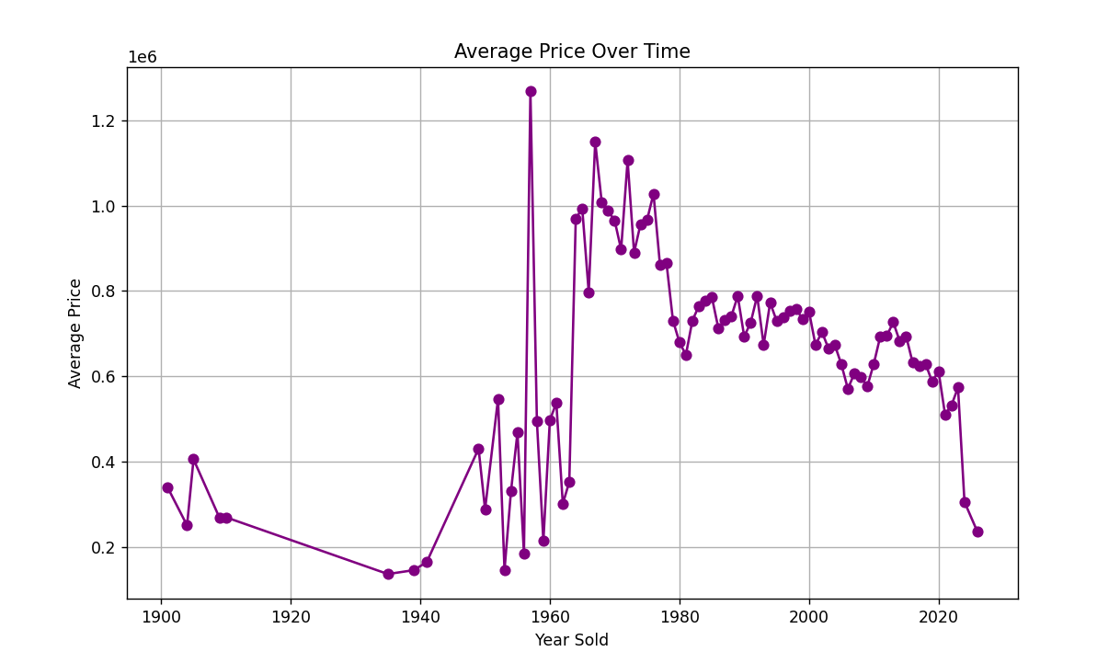
Correlation Between House Size and Price
A correlation analysis revealed a Pearson's coefficient of 0.02 between house size and price, indicating a weak but positive relationship. While larger houses generally command higher prices, the variability within this relationship suggests location and amenities play a critical role.
The log-transformed scatterplot of house size versus price provided clearer insights, showing clusters of properties where size mattered less than other factors, such as proximity to urban centers or school districts.
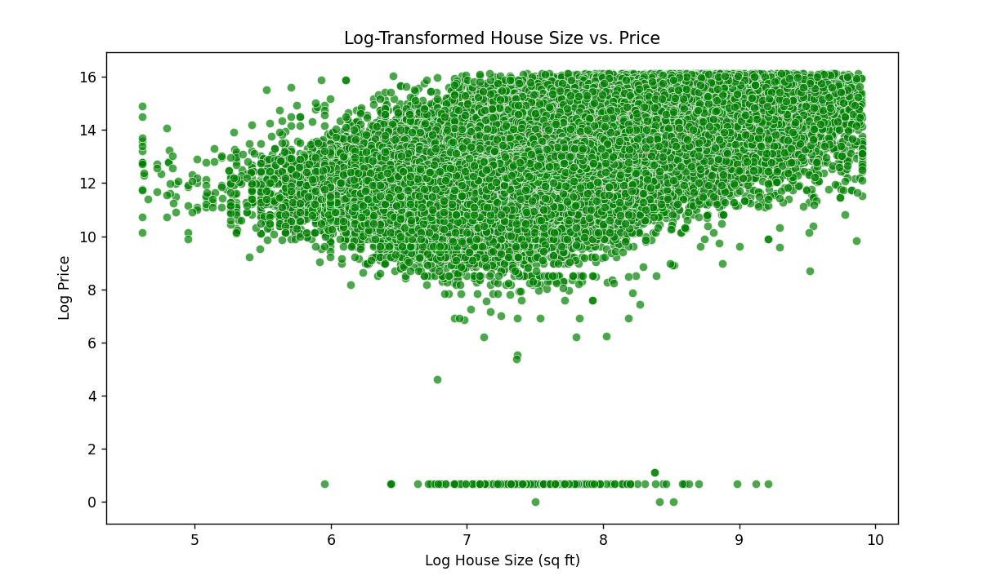
Regional Disparities and Clustering
KMeans clustering of price per acre illuminated stark contrasts between urban and rural property valuations. Urban areas demonstrated significantly higher price-per-acre values, reflecting the premium placed on limited land availability. In contrast, rural properties clustered at lower price ranges due to the abundance of land and lower development density.
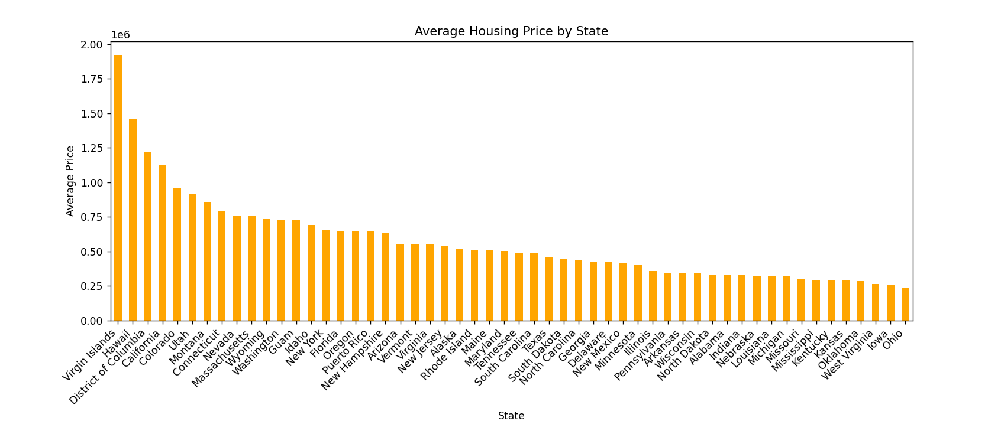
These findings highlight the need for location-sensitive pricing models to better understand and predict regional market behaviors.

Results
Key Insights
The findings of this study provide a comprehensive overview of the U.S. housing market:
- Housing prices are highly skewed, with the majority of properties valued below $1 million but a long tail extending into the multi-million dollar range.
- Regional disparities are pronounced, with Hawaii and the District of Columbia displaying the highest average housing prices.
- Temporal trends reveal a consistent increase in housing prices over time, punctuated by economic fluctuations.
- Clustering analysis further highlighted differences in property valuations between urban and rural areas.
- Log transformations proved valuable for improving the interpretability of price and size distributions, enabling more accurate modeling and visualization.

Conclusion
The U.S. housing market is a complex ecosystem influenced by myriad factors, including property characteristics, location, and broader economic trends. This analysis provides insights into key dynamics, from regional variations to temporal price trends. By combining robust data preparation with advanced statistical and machine learning techniques, this study offers a detailed perspective on housing market patterns, empowering stakeholders to make informed decisions.

Further Directions
- Incorporate New Variables: Adding features like proximity to amenities, transportation, and school quality could enhance predictive modeling.
- Segment the Market: Analyzing luxury versus affordable housing separately may yield deeper insights into market segmentation.
- Explore Economic Impacts: Investigating the effects of recessions, interest rates, and zoning laws could provide policy-relevant findings.
- Assess Affordability: Examining housing affordability in relation to income levels would address a critical societal issue.
- Urbanization Trends: Studying the influence of urban sprawl and zoning regulations on price trends could benefit urban planners and policymakers.

